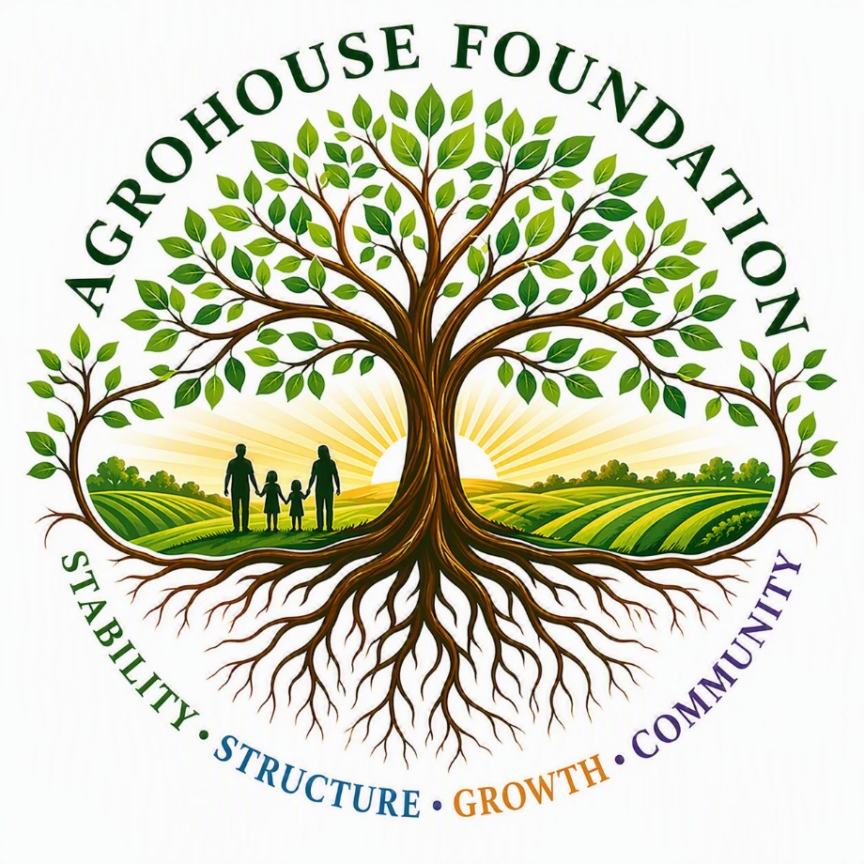
Guided Site Walkthrough
Campus Layout and Operational Experience
Prepared for: Amy Crow
Prepared by: Maggie Baty Founder of AgroHouse Foundation™
July 1, 2026

July 1, 2026
Hey Amy,
I couldn’t decide what I wanted to send you first, so I built this guided tour just for you so you can picture the overall foundation project. I’m still working on the executive summary but be on the lookout because it’ll be coming sooner rather than later!
Attached is a guided site tour written to walk you through the entire AgroHouse Foundation™ property step-by-step, as if you were physically moving through experiencing the future planned educational tour. The goal of this document is to make the layout and structure easy to visualize, rather than presenting it in an abstract or technical format.
This walkthrough focuses specifically on the physical design of the campus and farm systems, including: - How the property is laid out from north to south - How people, food, and materials move through the space - How different environments are separated and connected - Where supervision, access control, and safety systems are built into the design and is meant to be read as an experience, so you can get a feel for how the system functions as a whole.
At this stage, this reflects the **build-out and structural design only**. I have not included the workforce, education, or training program details, as that portion will be developed separately and not by me. My area is just the farm and the build-out of the entire foundation. You’ve heard me describe it enough you already know what the AgroHouse Foundation™ is, what the mission and core values are so I’ll not repeat them until the executive summary. Please keep in mind that I’ve already designated security gates/cameras in the appropriate places.
From your perspective, I would really value your thoughts on: - The overall structure of the environment - How movement and boundaries are defined - The balance between supervision and personal space - The interaction between residential, public, and operational areas - Anything that stands out from a behavioral or psychological standpoint.
There’s a lot here, so there’s no expectation to absorb everything at once—this is just meant to give you a clear picture before we meet. I appreciate you taking the time to look it over, and I’m looking forward to talking through it with you on the 20th.
Thank you,
Maggie Baty
Founder of AgroHouse Foundation™

The North Side Guided visual walkthrough
The guided tour begins once you leave through the back door of the main office building of the AgroHouse Foundation™ facility. There is one path that runs straight south through the north compound. Around you are other walking/running paths with benches scattered along the path sprinkled with beautiful flowers, fruit trees, greenery, and pollinator stations. On the left side of the path separated by fencing are 2 male AgroHouses™ and on the right are 2 female AgroHouses™ each AgroHouse™ has its own living space with an attached 1-acre hoop house for learning/working their own crop systems. The AgroHouse™ is a vocational housing system that provides education and training. They actively learn the necessary skills for growing, maintaining, and harvesting fruits and vegetables. They then are required to learn necessary workforce training by either culinary education/training or by selling fruits and vegetables to the public at the farmstand. The food is used to not only bring revenue back into the no profit but to feed the residents of the program and it’s distributed to outreach programs as prepared meals and food boxes for the homeless. As you continue along the path you see a small basketball court, horseshoe area, a small rec field for tossing footballs/playing soccer and a playground used by the residents of the AgroHouse’s™ for socializing and family reunification. As you proceed south along the path you approach a biosecurity barrier. This barrier is what separates the people side from the vegetable production side. At this biosecurity barrier the guide explains: what the barrier is, where you’ll see them, and why it’s necessary to wash boots or use booties over our shoes.
The South Side Guided visual walkthrough
Booties are on, boots are washed and entry through the biosecurity barrier opens into the north edge of the working farm. Everything is designed to be both productive and visually instructive so as you step onto the defined educational path, you’re immediately surrounded by structured growing systems. On one side, you see organized raised bed crop systems, used for vegetables and greens. These beds are neat, repeatable, and clearly maintained—showing how food is grown in a controlled, teachable way rather than scattered across open land. Beyond the raised systems are deeper crop areas, where root crops and seasonal plants like melons and pumpkins are arranged in longer rows, nothing is random or unplanned. As you continue forward, the path opens into our intentionally designed:

FlowerBerry Corridor
On one side of the path is a corridor of strawberries, blueberries, blackberries, and raspberries. Visitors are handed a small basket and are invited to taste, pick, and connect directly with the berries. On the other side there’s a beautiful spread of sunflowers of various heights that line the edge of the path. Beyond that, rows of corn create a layered effect—a living wall of color, height, and movement. The guide explains how sunflowers grow and explains how they follow the sun as it moves throughout the day. If the flowers are in full bloom you’re told you can pick one on your way back to the North campus and continue along the path until you come to another biosecurity barrier and boot wash station. The guide explains “Everything inside this area involves animals, manure systems, and controlled environments. We don’t go in or out casually everything is intentional.”
Livestock education path – cattle, swine, waterfowl, and pigeons
Once properly prepared, you step through the barrier and enter a different environment. The first thing the guide points out for you to observe is cattle grazing, sunning, or enjoying a nice cool dip in water and as you continue along the path. The guide explains how grazing is managed, how movement is controlled, and how these systems support production as you transition into the swine area and observe the feeder pigs playing in mud and behaving as pigs do. The guide points out how structure keeps both animals and people safe as you come around the curve in the path and opens into an area with picnic tables for a water and a choice for a snack that was grown/harvested at the farm while you enjoy the sound of the waterfall while watching our beautiful geese and ducks in their habitat or enjoy an aerial show of roller pigeons dancing in the air. The guide gives a short lesson on goose behavior and how the geese and pond help to fertilize the crops in the early stages of growing. After the break the guide tells you: “Every system is separate for a reason, we protect what we enter and what we leave.” From this point we transition from waterfowl observation into the Poultry Systems. The guide leads you to a handwashing and boot washing station to once again wash hands, boots, or change booties if necessary and then guides the tour over to the incubation station and brood houses where you can observe chicks peeking out from their mothers wings or mother hens teaching chicks how to eat and drink or look through an observation window where you can learn all about incubation and observe trained staff caring for newly hatched chicks or eggs in various stages of hatching. The guide takes you around the last curve and oh what a sight you see but a bunch of tiny houses as far as the eye can see where breeders and feeder chickens roam and forage free. Big ones and little ones, the guide will educate

you on everything about chickens until you transition into the final livestock area known as the hands-on fun zone of Jersey Giants, Leghorns, and Plymouth rock chickens. The guide explains “If they can be caught safely, interaction is allowed if not, we observe.” This reinforces control and respect for the animals while allowing kids/adults to run and interact with some of the sweetest docile chicken breeds that lay the most eggs. Leghorns and Jersey Giants give a new meaning to fast food but are gentle creatures. Jersey Giants Plymouth Rock chickens are sweet and love to be held by humans. So, if you think you’re fast enough and think you can catch it, you can hold it and pet it. After a short turn trying to catch some fast food we come to a hand washing station and after washing your hands (only if you handled chickens) your then given the option of stepping into a teaching pen where special selected animals are placed for a more hand-on learning experience or you can choose to play with goats in their very own playground where they like jump, faint, and headbutt you until you can’t stop giggling or until you get headbutted by one with big eyes that are saying “hey I’m cute, take me home!” After a period of playing with the goats or learning in the teaching pens your then guided back through the same barrier you came in from and once more wash hands, boots, or change booties to transition back into the crop zone once more to pick a Sunflower before walking back through the barrier transitioning you into the North Campus to finish the tour and ending the AgroHouse™ experience at the farm stand where you can purchase organic fruits and vegetables grown at the AgroHouse Foundation™

